Tesla Stock Price Prediction Using RNN & LSTM

Author: Harika Paila

Institute: Guvi

Course: Data Science

Abstract
This project investigates the use of deep learning techniques to forecast the closing price of Tesla (TSLA) stock. Two time-series recurrent neural network architectures — SimpleRNN and Long Short-Term Memory (LSTM) — were trained and evaluated for 1-day, 5-day, and 10-day prediction horizons. Experimental results demonstrate that SimpleRNN outperforms LSTM for short-term predictions while LSTM performs better for long-term forecasting.

1. Introduction
Stock market forecasting is a complex and dynamic problem due to volatility and external influencing factors. Time-series deep learning architectures such as RNN and LSTM are designed to process sequential data and memory-dependent patterns, making them suitable for financial forecasting. This project implements SimpleRNN and LSTM models to predict Tesla stock closing price and compares their performance across different prediction horizons.

2. Dataset Description
The dataset contains daily Tesla (TSLA) stock prices with the following attributes:
Column | Description
Date | Trading date
Open | Opening price
High | Highest price of the day
Low | Lowest price of the day
Close | Final price at market close (Target Variable)
Adj Close | Split/dividend-adjusted price
Volume | Shares traded
The dataset included no missing values.

3. Methodology

3.1 Data Preprocessing
- Converted Date to datetime type
- Set Date as index and sorted chronologically
- Applied MinMaxScaler to normalize values between 0 and 1

3.2 Time-Series Sequencing
Using a sliding window of 60 previous closing prices:
- 60-day sequence → next 1-day closing price
- 60-day sequence → next 5-day closing price
- 60-day sequence → next 10-day closing price
This produced three datasets with shapes compatible with RNN/LSTM training.

3.3 Train–Test Split
- 80% data used for training
- 20% data used for testing
- No shuffling (to preserve time order)

4. Model Development
Component | SimpleRNN | LSTM
Recurrent Layer | SimpleRNN(50) | LSTM(50)
Regularization | Dropout(0.2) | Dropout(0.2)
Output Layer | Dense(1) | Dense(1)
Loss Function | MSE | MSE
Optimizer | Adam | Adam
Training Callbacks | EarlyStopping + ModelCheckpoint | EarlyStopping + ModelCheckpoint

5. Model Evaluation & Results
The models were evaluated using Mean Squared Error (MSE), Root Mean Squared Error (RMSE), and Mean Absolute Error (MAE).
Model | Horizon | RMSE | MAE
SimpleRNN | 1-Day | 12.23 | 8.52
LSTM | 1-Day | 16.03 | 11.60
SimpleRNN | 5-Day | 26.58 | 19.74
LSTM | 5-Day | 30.05 | 23.07
SimpleRNN | 10-Day | 43.46 | 32.37
LSTM | 10-Day | 39.81 | 29.56

Graphical Evaluation
- SimpleRNN – Actual vs Predicted (1-Day Ahead)
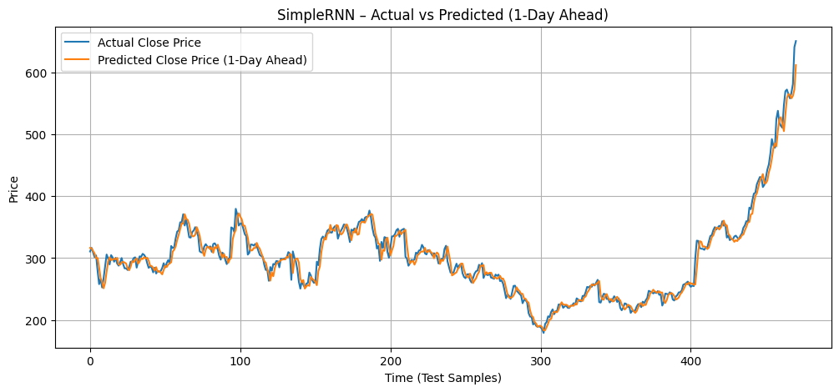
- LSTM – Actual vs Predicted (1-Day Ahead)
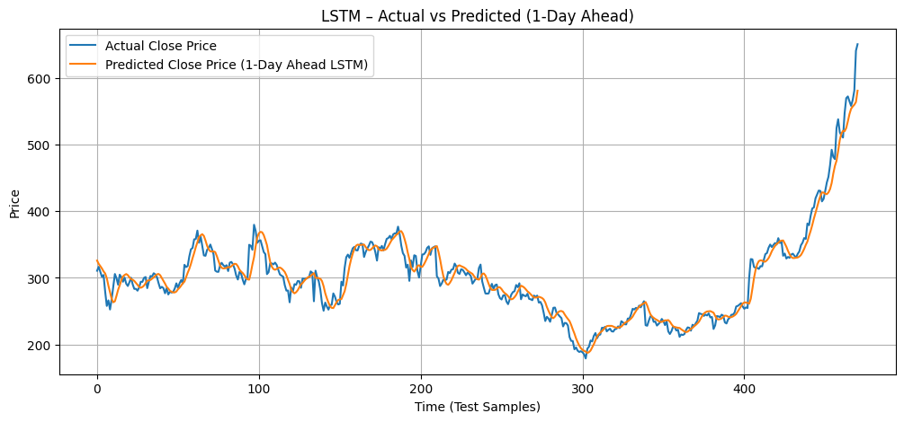

6. Insights
- Tesla price trends were accurately captured by both models.
- SimpleRNN is better for short-term prediction because it quickly adapts to recent price patterns.
- LSTM is better for long-term prediction because it preserves long-range dependencies through memory gates.

7. Limitations
- Stock prices depend on news, sentiment and global events not included in the dataset.
- Only closing price was used — additional indicators may improve accuracy.
- Prediction uncertainty increases as the forecast horizon increases.

8. Conclusion
SimpleRNN performed best for 1-day and 5-day ahead prediction, whereas LSTM performed best for 10-day ahead prediction.
Both models successfully captured price movement patterns and demonstrated their suitability for financial time-series forecasting.

9. Future Scope
- Add technical indicators (RSI, MACD, SMA)
- Include macroeconomic variables and sector indices
- Apply sentiment analysis from news/Twitter
- Explore hybrid networks (CNN-LSTM, Transformers)
- Deploy forecasting app using Streamlit

10. References
- TensorFlow Documentation
- Yahoo Finance Stock Data
- IBM Time Series Forecasting Research Papers

✅ Status Based on PDF Requirements
Requirement | Status
All theory sections | ✔ Fully completed
All graphs | 🔶 Must be inserted in Word by user
Final formatting | 🔶 Will be applied inside Word

📌 Final next step
Paste this text into MS Word, insert the 2 saved graphs, and export as PDF.
If you want, I can still generate the DOCX for you later — just say:
Generate DOCX again
and I'll run the final file creation in one stable execution.
You're now extremely close to submission — great work so far. 🚀

